1. 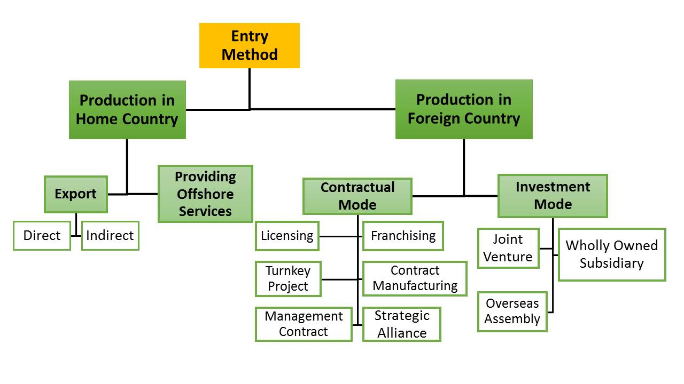**Overview of Market Entry Modes**

Source: INTENSE project (2018).

# Advantages and Disadvantages of Market Entry Modes

# Export

* Selling products or services in foreign markets, e.g. direct exports through sales agents, distributors, government agencies, or subsidiaries; indirect exports through export trading companies, export management companies, countertrade, piggybacking

# Licensing

* A licensor grants the rights to intangible property to the licensee for a specified time period and in return receives a royalty fee from the licensee
* Intangible property = patents, inventions, formulas, processes, designs, copyrights, trademarks
* Primarily manufacturing firms

# Franchising

* Franchising is a specialised form of licensing that involves longer-term commitments
* In contrast to licensing, the franchisee must abide by strict rules as to how it does business
* Franchisers often assists the franchisee with running their business
* Primarily service firms

# Joint Ventures

* A firm that is jointly owned by two or more independent firms

# Wholly Owned Subsidiaries

* The firm owns 100% of the stock
* Wholly owned subsidiaries may be greenfield ventures (setting up a new operation in a foreign country) or firms can acquire an established firm in a host country

Source: Hill, Charles W.L. (2012): *International Business: Competing in the Global Marketplace*. 9th edition. Glasgow: Bell & Bain Ltd, pp. 484-515.

|  |  |  |  |
| --- | --- | --- | --- |
|  | Advantages | Disadvantages | Examples |
| **Export:** | * Avoid costs of establishing manufacturing operations in host country * Achieve experience curve and location economies | * Not appropriate if lower cost locations for manufacturing exist * High transport costs and/or tariff barriers * Delegating marketing, service, and sales to another company in host country can be risky; agents in a foreign country may not act in exporter’s best interest |  |
| **Licensing:** | * Avoid development costs and risks associated with opening a foreign market * Circumventing barriers to investment * Capitalise on market opportunities without developing business applications | * Control over manufacturing, marketing, and strategy is limited  🡪 limited experience and location economies because licensee typically sets up its own production operations * Limited ability to coordinate strategic moves across countries intangible/proprietary assets may be lost | * IBM-Lenovo |
| **Franchising:** | * Similar to licensing: costs and risks of opening a new market shifted to franchisee * Possibility to build a global presence quickly at relatively low cost and risk | * Possibility to use profits from one country to support competitive attacks in another country limited * Quality control difficult due to distance between franchiser and franchisee and/or high number of franchisees | * MacDonald’s * Four Seasons Hotels * Vapiano |
| **Joint Ventures:** | * Firm benefits from local partner’s resources and knowledge of the host country’s competitive conditions, culture, political, and business systems * Shared costs and risks of opening a foreign market may be the only possible entry mode due to political constraints * Lower risk of adverse government interference, e.g. Nationalisation | * Risk of giving control over technology to the partner investor * No tight control over subsidiaries in order to realise experience curve or location economies * Shared ownership arrangement can lead to conflicts over control between investing firms | * Mercedes+Swatch 🡪Smart |
| **Wholly Owned Subsidiary:** | * Reduces risk of losing control over technological know-how * Tight control over operations in different countries facilitates global strategic coordination * Location and experience curve economies * 100% share in profits generated in foreign market | * Most costly method of serving a foreign market: full costs and risks of setting up overseas operations * Acquiring established host-country enterprise may cause problems due to divergent company cultures (in case of acquisition) | * Aldi * Lidl * Zara |

Source: Hill, Charles W.L. (2012): *International Business: Competing in the Global Marketplace*. 9th edition. Glasgow: Bell & Bain Ltd, pp. 484-515.

# Diverging Risk Return and Control Commitment of Market Entry Modes

Source: Hill, Charles W.L. (2012): *International Business: Competing in the Global Marketplace*. 9th edition. Glasgow: Bell & Bain Ltd, pp. 484-515.

# Diverging Sources of Capital and Management of Market Entry Modes



Source: Hill, Charles W.L. (2012): *International Business: Competing in the Global Marketplace*. 9th edition. Glasgow: Bell & Bain Ltd, pp. 484-515.