For the Love of Bread
Case Study

This case was written by Prof. Dr. Tine Lehmann, solely for teaching purposes at HTW Berlin. While the case is based on a real situation, all names, places, the industry and some peripheral facts might have been disguised. The case is solely developed for teaching purpose and is not intended as an endorsement or citable data.

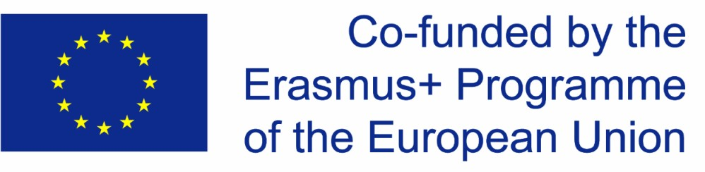
I

The average German eats 56 kg of bread per year (Statista 2013). And even though that means the German consumer is just about average in the EU, German bread has always had a specific reputation. Since 2014, German bread baking culture is even considered to be UNESCO world heritage. Nevertheless, traditional bakeries are struggling with the extremely low-price competition in the supermarkets. More and more traditional bakeries are closing; and more bread is sold in the supermarkets, containing long lists of additives.

The brothers Mathias and Peter Altus wanted to change that trend. They were frustrated with the low quality of bread in supermarkets and missed good traditional and additive-free bread. In 2012, they started their own business “bread fans” with two friends who were trained bakers, and started to produce self-backing bread sets that follow traditional bread baking culture and ingredients. They aimed at creating a social enterprise, producing organic products, using emission-free transport systems, and donating part of their income to welfare institutions.

They created an online shop where customers can order baking mixes for bread, from typical bread (that can be found in a bakery) to more unusual bread with fruits and herbs (all organic), vegan, and even get gluten-free bread mixes. The instructions for the bread were designed to be easily understood. The package includes flour, a rising agent, herbs, fruits or nuts, and even the baking parchment.
"Dieses Foto" von Unbekannter Autor ist lizenziert gemäß CC BY-ND

“Bread fans” took off quite well in the beginning. In 2015, a good childhood friend of the Altus brothers, Marc, emigrated to the United States, and proposed the idea of going international. Marc had already spent some years in the US at high school and college and was convinced that the self-baking bread sets would be a success in the US market. The Altus brothers liked the idea, especially as Marc would work free of charge in the beginning. They trusted his market experience and knowledge.

At first, Marc promoted the bread baking sets in German Expat communities in the United States. “Bread fans” realised soon that it had to invest quite some money and time to adapt to the US market. Not just the instructions had to be translated as it first thought, but also the list of ingredients had to be adapted, as not all ingredients were available in the USA. Furthermore, it realised that the stoves in the USA seemed to work a bit differently and most bread baking sets just did not come out right. Hence, Marc tried to experiment with different stoves and baking times and temperatures, but it did take quite a while till it had adapted its product to be functioning in the US market. By that time, it had already lost some trust within the German Expat community. Hence, Marc tried to target another customer group: young Americans, eco-friendly, big-city dwellers. However, that was not very fruitful either, as most of them simply did not like the hard, unsweetened German bread. Additionally, customs and shipping made the baking sets quite expensive and the “bread fans” had to abandon its idea of emission-free transport systems in favour of price.

Hence, instead of engaging in the next step and adapting the product range, the “bread fans” decided to stop its internationalisation process.

Can you help the “bread fans” and try to find out what went wrong?

Questions to support the analysis:
- What kind of business do the Altus brothers have? In what stage of business development are they and what does it mean for the different issues in their company?
- What were their motives for internationalisation and what are the core problems in their internationalisation to the US market?

Annex:

Figure 1: Bread consumption in kg in the EU per capita (source: www.statista.de)

