C.3.3. Case Writing
Guide & Checklist for Students

What is a teaching case study and why write one?
A case study is a story or scenario in narrative form that presents a real business problem, challenge, or opportunity and is used to train students' analytical and problem-solving skills in higher education. Cases are (often) based on real events and present readers with a challenging business scenario that they have to solve. Learning from examples is an effective learning technique for business students. Writing your own case study is an excellent way of sharing the experience and knowledge you have gained while working with a company with other business students. It helps you to reflect on the company's business problem from a different perspective and train your writing skills.

How does a case study differ from an academic article?
A teaching case study differs from an academic piece of writing in two substantial ways: first, while a research article provides answers to a specific research question based on the analysis of empirical evidence or data, a case study is open ended; therefore, it does not provide an analysis or diagnosis of the business problem. Second, the writing style of case studies is closer to that of a thriller than to an academic article. To grab the reader’s attention, it is pivotal that case studies have a good story line and interesting characters. However, teaching case studies and academic articles also have things in common. They both include in-text citations and lists of references and they are both written objectively. They present the reader with facts and, although the author(s) should present more than one side of the story, they should not take sides.

How does a case study differ from a consultancy report?
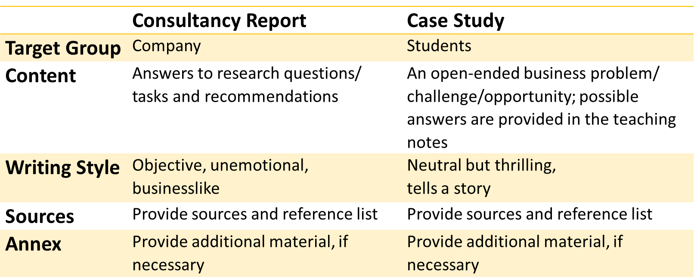
Source: INTENSE

What are the components of a case study?
Roughly, a teaching case study consists of the actual case and a teaching note. The case starts with an introduction (ca. 1 page) that sets the stage of the case and provides answers to the 'w-questions' (What, why, where, who). The body of the case (ca. 5-7 pages) provides some background information on the company and tells the whole story, including what has happened so far, the situation faced by the
company, the actions the company has taken so far, and the possible options. The conclusion (ca. 1 page) of the case study is a synthesis of the case. Depending on the level of difficulty of the case, the conclusion can end with some open questions for which students need to find answers.

The teaching note (ca. 3-5 pages) is a vital part of the case study and provides information and instructions for teachers. Without a good teaching note, lecturers are unable to use your case study in their course. The teaching note must include the following elements:
- A synopsis of the case that summarises the core business problem/business opportunity
- The target group and the previous knowledge the target group should have
- The learning objectives of the case related to skills, activities/methods, and knowledge
- A solution to the case that makes use of theoretical concepts and/or analytical tools from the international business literature
  - The solution can also include recommendations for the company and an implementation plan
- A list of recommended reading for lecturers
- A list of references

Check the presentation on case writing for optional elements of the teaching note!

How to write a case study?
Step 1: Before you start writing your case, you need to be clear on
a) what your case is about (what is the core business problem or opportunity?);
b) which theoretical concepts and tools it relates to (e.g. internal and/or external analysis using the SWOT matrix; market entry modes, etc.);
c) what readers learn from working with your case; and
d) for whom you are writing the case (bachelor or master students and which programme(s) of study?).
Hence, you should start with defining the overall subject, the theoretical concepts/tools it relates to, the learning objectives, and the target audience of your case. These are important elements of your teaching note.
Step 2: Next, you should develop the story line of your case. Who are the characters of your case and from whose perspective do you tell your case? With which event does your story begin and with which crucial event/decision point does it end? A case that does not tell an interesting story will not grab the reader’s attention, so make sure to reserve enough time to develop a good story line.
Step 3: You are now ready to write the introduction of your case. Take a look at the two introduction examples and/or the introductions of cases you have worked with for some inspiration. Before you continue, send your introduction and answers to the four questions raised above to your instructor and ask him/her for some feedback. Remember to include in-text citations while writing your case.
Step 4: Once you have completed these steps, you have two options. Some people prefer to write the teaching note first. You already worked on points 1, 2, and 3 of the teaching note (s. above). The solution to the case (point 4) is the research you conducted for your company. Just as for your company report, the solution should make use of specific theoretical concepts/tools to structure your analysis, e.g. Porter’s 5 forces, a SWOT matrix, etc.
Add some additional readings for lecturers (point 5). The lecturer did not work with the company for several weeks and needs to familiarise herself/himself with the case. In order to be able to teach the case, lecturers need to read up on the issues and concepts you have studied throughout your consulting project. Depending on how complex your case is you might want to add some additional elements to your teaching note, e.g. a list of stakeholders, a timeline, or an epilogue that tells the lecturer what the company actually decided to do.
Step 5: Alternatively, you could continue with writing the body of your case and the conclusion before writing your teaching note. Before you start writing, develop a clear structure for the body of your case. You need to decide which pieces of information you want to provide in which section and where you want to place hints or red herrings in your text. Use sub-headings to structure the body of your case.
Step 6: Once you have written your case and teaching note, add a list of references that you have used for your case study (point 6). Make sure to reserve enough time for the final language and format editing. In particular, if several people were involved in writing the different sections of your case, one person (with good English skills) should go through the whole case again before you hand it in.
Check out the additional readings and example case studies for some inspiration!

Check List for Case Studies
Criteria related to the case content
- Does the case grab the reader's attention?
- Does your case have a story line and characters?
- Is the core business problem/opportunity of your case clear?
- Is your case open-ended, e.g. does not provide a diagnosis or analysis of the problem?
- Does your case provide enough (but not too much) information for students to solve the case?
- Does the teaching note provide a solution to the case using theoretical concepts and/or analytical tools from the international business literature?
- Is the structure of your case clear and logical?
- Are the learning objectives of your case clear?

Formal criteria
- Is your case complete (introduction, body of the case, conclusion, teaching note, references)?
- Did you include in-text citations and a (complete) list of references?
- Did you check the spelling, grammar, and language of your case study?
- Is the level of difficulty of your case study appropriate for your target group?

