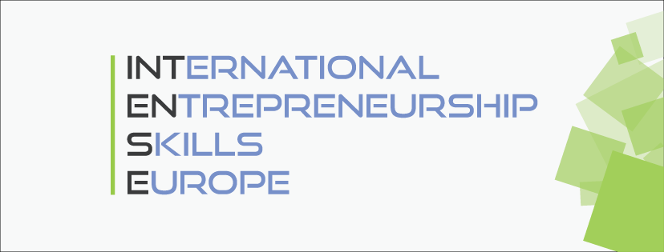

Multiplier event Croatia
Osijek, March 22, 2019

at
Faculty of Economics in Osijek

Program
11:00 | Opening and welcome speech - prof. Boris Crnković, dean of Faculty of Economics in Osijek
11:10 | Erasmus+ project Intense – prof. Sunčica Oberman Peterka, project leader
11.15 | Consultancy reports presentation  - Ortostep Ltd Osijek  - Europlast Ltd Donji MIholjac  - LadzLife Ltd Osijek  - Žito Ltd – product line Dobro  - Carta Ltd Osijek  - Tinker Labs Ltd Osijek
12:45 | Q & A
13.10 | Networking and lunch
14:00 | End

